Data Transformation and Calculated Column Creation
DATA TRANSFORMATION:
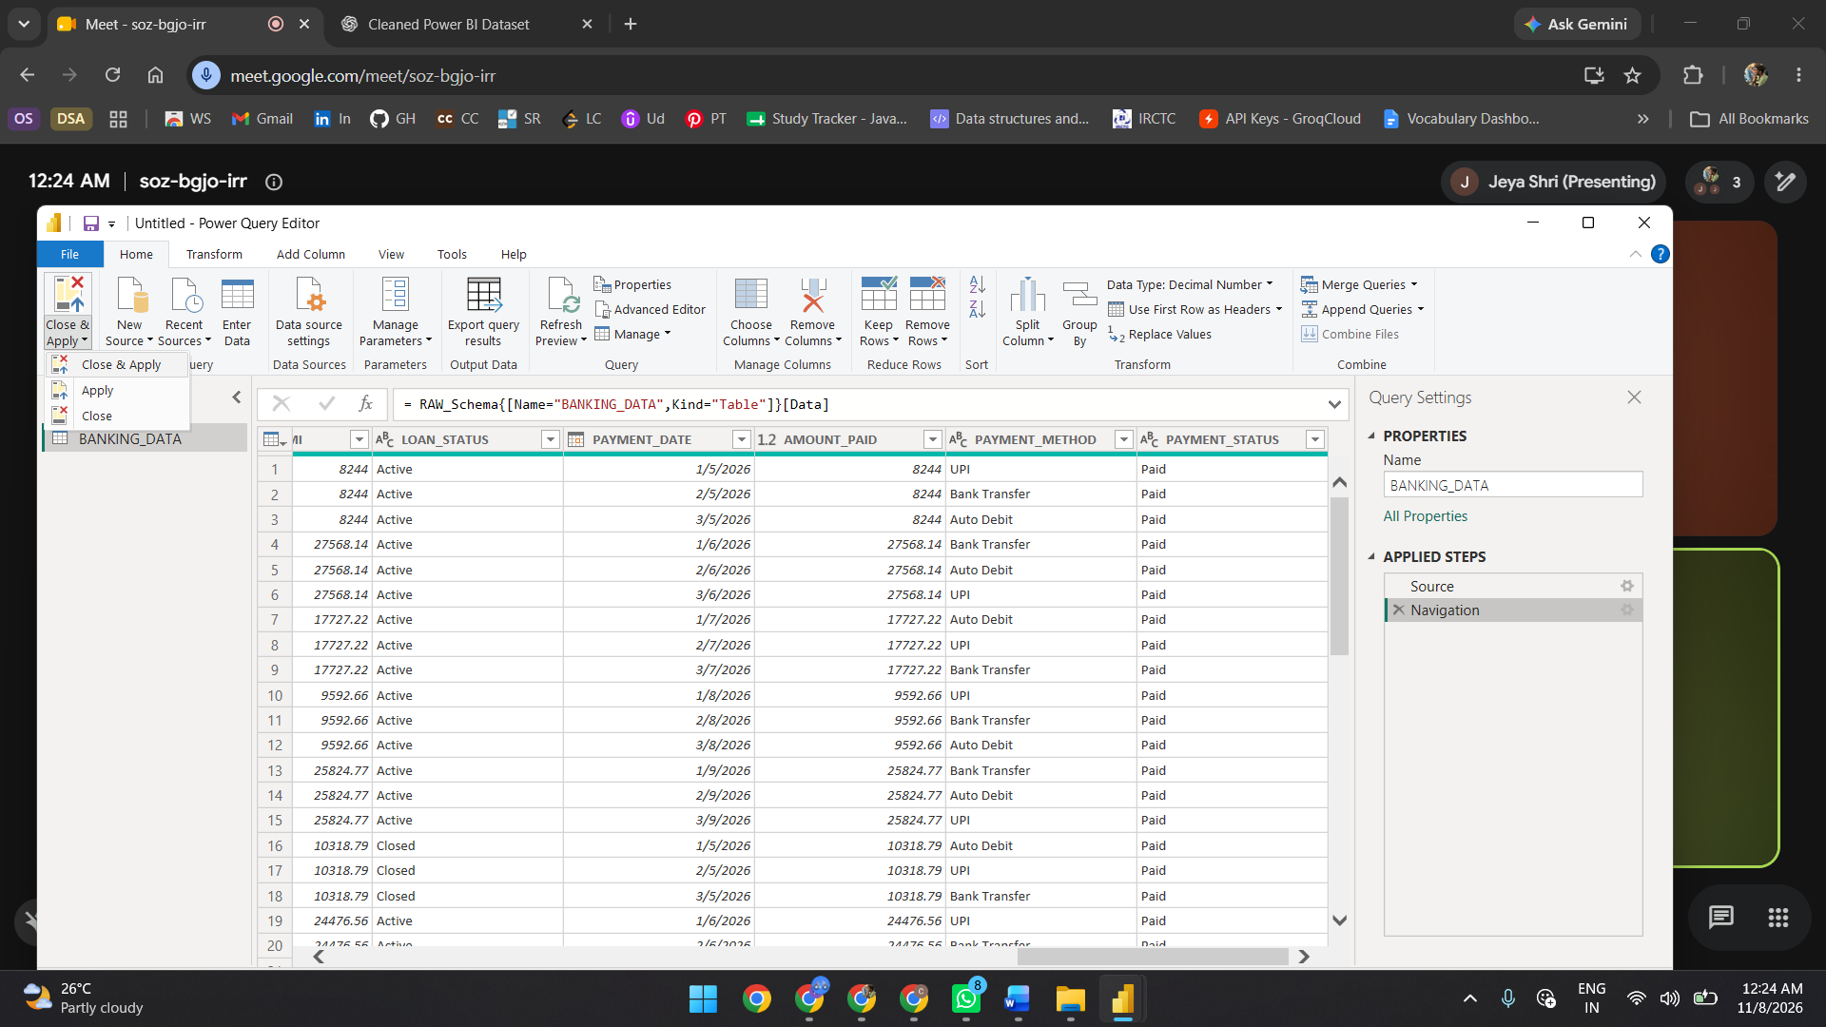
CUSTOM COLUMN CREATION:


